DESIGN AND ANALYSIS OF ALGPROTHMS (10CS43)
Unit – I
TOPICS
Chapter 1: Introduction, Notion of Algorithm

Chapter 2: Review of Asymptotic Notations
Mathematical Analysis of Non-Recursive Algorithms
Mathematical Analysis of Non-Recursive Algorithms

Chapter 3: Brute Force Approaches
Introduction
Selection Sort
Bubble Sort
Sequential Search [07 Hours]
Chapter - I

What is an Algorithm?
An algorithm is a sequence of unambiguous instructions for solving a problem, i.e., for obtaining a required output for any valid input in a finite amount of time.

This definition can be illustrated by a simple diagram.

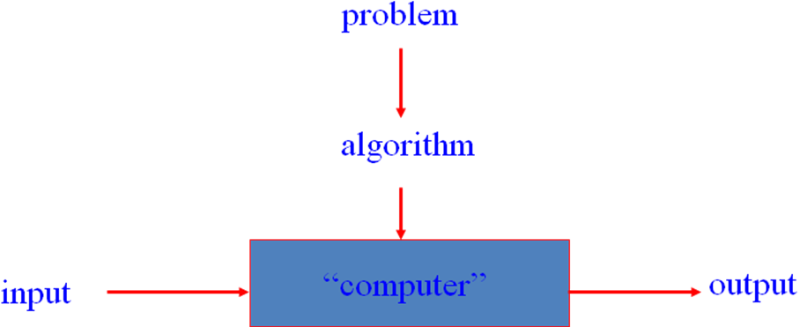
The reference to "instructions" in the definition means that there is something or someone capable of understanding and following the instructions given.

As examples illustrating the concept of algorithm, consider three methods for solving the same problem: computing the greatest common divisor of two integers. These examples will illustrate several important points:
- The nonambiguity requirement for each step of an algorithm cannot be compromised.
- The range of inputs for which an algorithm works has to be specified carefully.
- The same algorithm can be represented in several different ways.
- Several algorithms for solving the same problem may exist.
- Algorithms for the same problem can be based on very different ideas and can solve the problem with dramatically different speeds.

The greatest common divisor of two nonnegative, not -both-zero integers m and n, denoted gcd(m, n), is defined as the largest integer that divides both m and n evenly, i.e., with a remainder of zero.

First method is, Euclid's algorithm is based on applying repeatedly the equality gcd(m, n) = gcd(n, m mod n) until m mod n is equal to 0; since gcd(m, 0) = m, the last value of m is also the greatest common divisor of the initial m and n.

For example, gcd(60, 24) can be computed as follows:
gcd(60, 24) mod(60,24) =12

gcd(24, 12)

gcd(12, 0) = 12.
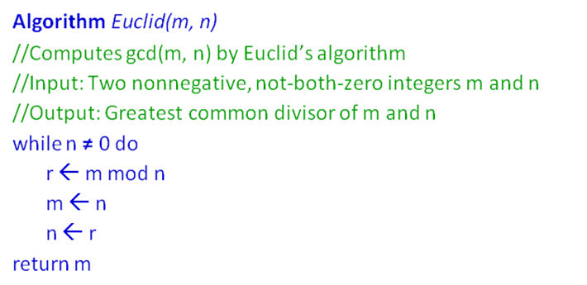

The second method selects the smaller of two numbers m & n, which is denoted by t = min (m, n). So we can start by checking whether t divides both m and n: if it does, t is the answer; if it does not, we simply decrease t by 1 and try again.
For example, for numbers 60 and 24, the algorithm will try first 24, then 23, and so on until it reaches 12, where it stops.
Consecutive integer checking algorithm for computing gcd(m, n)
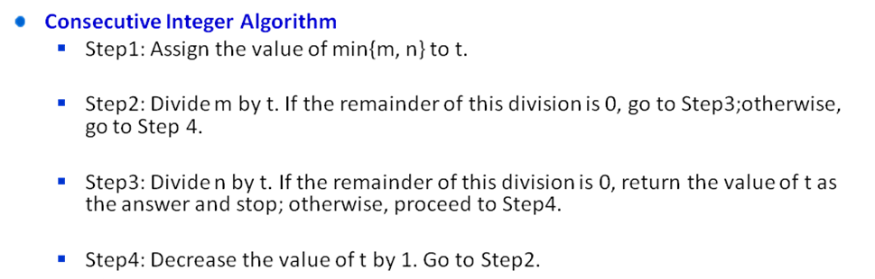
The third procedure for finding the greatest common divisor should be familiar to you from middle school.
Middle-school procedure
Step 1 Find the prime factorization of m
Step 2 Find the prime factorization of n
Step 3 Find all the common prime factors
Step 4 Compute the product of all the common prime factors and return it as gcd(m,n)

Thus, for the numbers 60 and 24, we get
60=2·2·3·5
24=2·2·2·3
gcd(60, 24) = 2. 2. 3 = 12.

In algorithm is of poorer efficiency, the middle-school procedure does not qualify, in the form presented, as a legitimate algorithm. Because the prime factorization steps are not defined unambiguously: they require a list of prime numbers.

Consider an algorithm for generating consecutive primes not exceeding any given integer n. It was invented in ancient Greece and is known as the sieve of Eratosthenes (ca. 200 B.C.). The algorithm starts by initializing a list of prime candidates with consecutive integers from 2 to n. Then, on the first iteration of the algorithm, it eliminates from the list all multiples of 2, i.e., 4, 6, and so on. Then it moves to the next item on the list, which is 3, and eliminates its multiples. The next remaining number on the list, which is used on the third pass, is 5. The algorithm continues in this fashion until no more numbers can be eliminated from the list. The remaining integers of the list are the primes needed.
As an example, consider the application of the algorithm to finding the list of prime’s not exceeding n = 25:

Ex: 2 3 4 5 6 7 8 9 10 11 12 13 14 15 16 17 18 19 20 21 22 23 24 25
2 3 5 7 9 11 13 15 17 19 21 23 25
2 3 5 7 11 13 17 19 23 25
2 3 5 7 11 13 17 19 23

For this example, no more passes are needed because they would eliminate numbers already eliminated on previous iterations of the algorithm. The remaining numbers on the list are the consecutive primes less than or equal to 25.

The algorithm for sieve of Eratosthenes is given below.
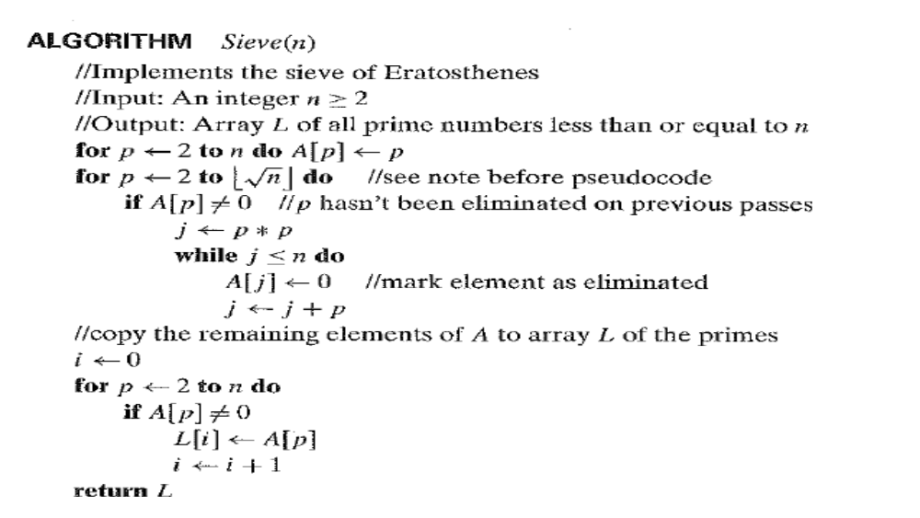

So now we can incorporate the sieve of Eratosthenes into the middle-school procedure to get a legitimate algorithm for computing the greatest common divisor of two positive integers. Note that special care needs to be exercised if one or both input numbers are equal to 1: because mathematicians do not consider 1 to be a prime number, strictly speaking, the method does not work for such inputs.

